1.Odd String Difference

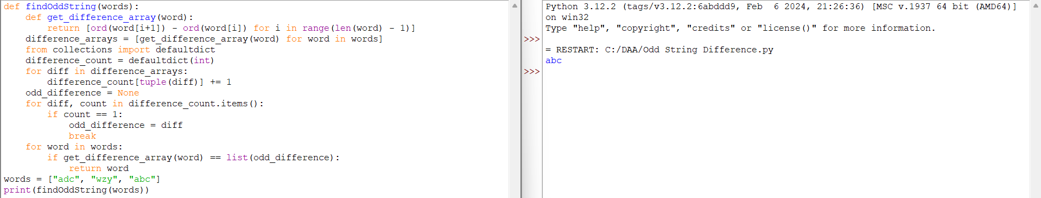

2.Words within two Edits of Dictionary

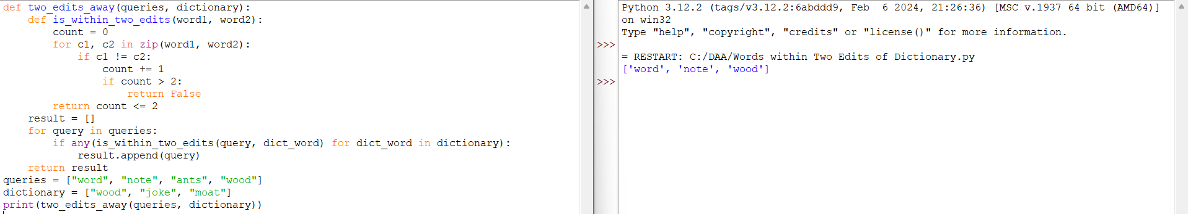

3.Next Greater element IV

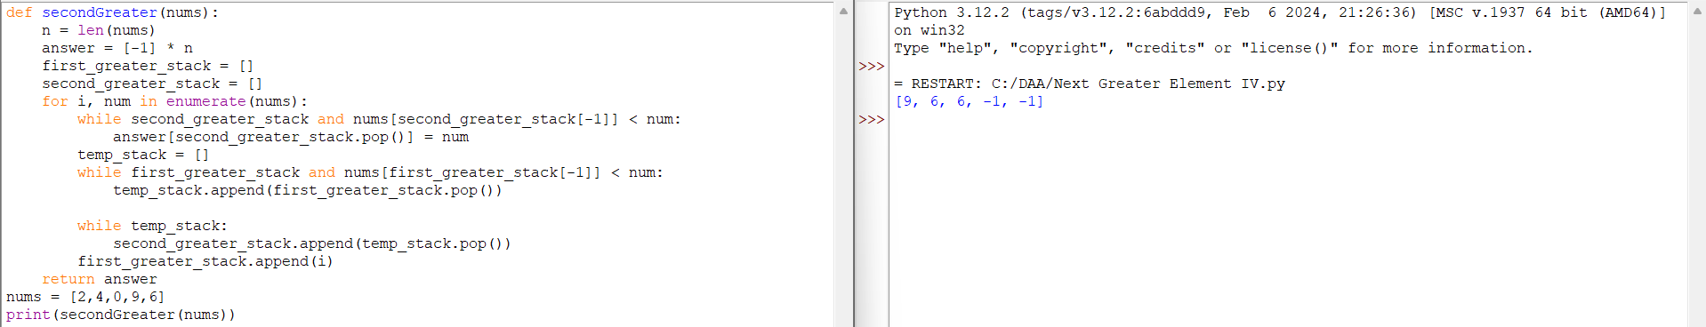

4.Minimum Addition to Make Integer Beautiful

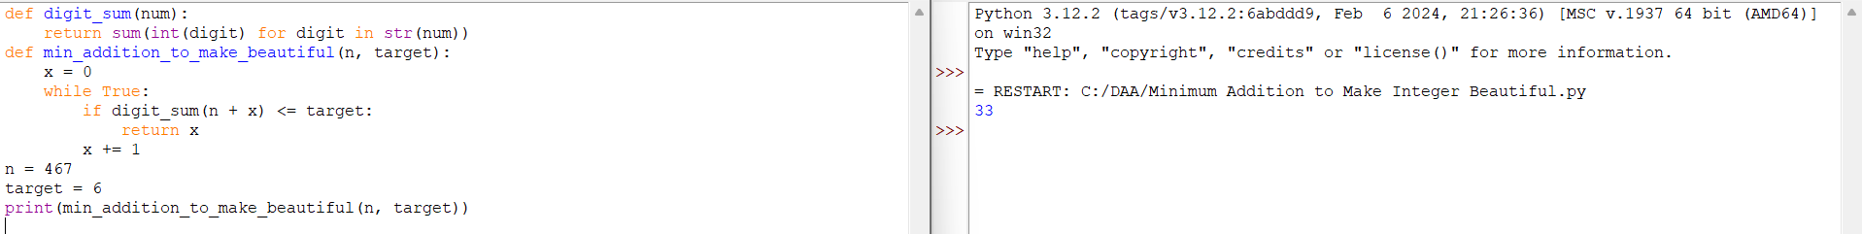

5.Sort Array by Moving Items to Empty Space

